Toronto Business College

Data Visualization

Assignment (5)

Case study - Tableau charts

Hand Out Date: 17/11/2021

Hand In Date:24/11/2021

Assignment Type: Workgroup(Maximum 4 Students Per Group)

Due Marks: 15%

Please put the Group’s students’ names and IDs clearly on top of each work document.

Assingment 5 Case Study TABLEAU Chart Application Exercise

Group-F

*Charitha Priya Dongari – 500191110*

*Katterapalli Venkata Satya Narayana Reddy – 500190693*

*Rumana Banu Iliyas Ahmed – 500186725*

*Rohan Bhatt – 500187633*

*Shivam Jolly – 500196452*

**REQUIREMENTS**

Note: global_superstore_2016 file (XLS format) is attached with this assignment.

1. You are requested to build Map-chart shows global sales and profit filtered by categories at the level of USA stores as the following: -
2. Map based on Longitude (generated) and Latitude (generated).
3. Use color plate to shows sum of Profit.
4. Size shows details about State.
5. The data is filtered on Category and Sub-Category.
6. The Category filter keeps Furniture, Office Supplies and Technology.

**Deliverable: -**

Word document that shows: -

Question 1> Describe the steps you followed to generate the charts : - ?

Answer 1>

To begin with our journey of how we have designed the analysis of our dataset that has been provided to us we before-hand have to study about the so called Tableau software on which we would be performing it : -

Tableau was founded in 2003 as the result of a computer science project at Stanford with the goal of improving the flow of analysis and making data more accessible to people through visualisation.

Making machine learning, statistics, natural language, and smart data prep more useful to augment human creativity in analysis is part of all this. And not only does it provide a comprehensive, integrated analytics platform, but it also provides proven enablement resources to assist customers in deploying and scaling a data-driven culture that drives resilience and value through powerful outcomes.

**Now Talking about the Functionality of tableau : -**

**The tableau has been allocated on several parts that we would be discussing upon it : -**

* 1. **Data Connection :** - Tableau has a unique identity to connect with several types of file and to get it analysed on a large scale.
  2. **Tools : -**

There are several tools that have been provided to us and lets talk about it briefly that make analysis easy : -

* + 1. **ShowMe :** - It has been a very crucial feature to let us know that after selecting the different dimensions and measure which all graphs could suit to provide us with a beautifull presentation of our data.
    2. **Marks :** - The marks card in Tableau gives you control over how the data is displayed in the view. The options on this card allow you to change the level of detail and the appearance of the marks without affecting the headers created by fields on Columns and Rows. It comprises of features like color , Label and Size and many more .
    3. **Filters :** - As the name suggests that it is meant to mark filters on the attributes which we would be using in it like which country to select ,which class to select and many more.
    4. **Dashboard :** - Get any attribute to add different pages to the graphs and let us know how it works and hence combining different pages or sheets to make a dashboard

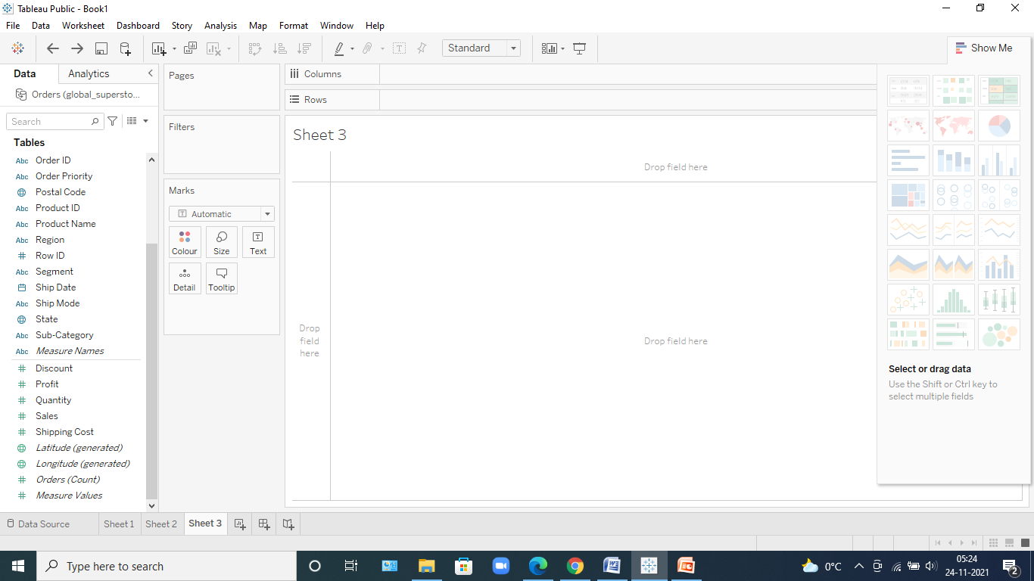

Now that we have talked about Tableau, let’s talk about each and every step of analysis taken by us for the assignment: -

STEP 1 : - Lets download the dataset that has been provided to us , Over here we have been given the excel dataset on Global purchases of 2016.

* 1. We clicked on the excel sheet and the data got loaded.

STEP 2 : -

Once the data gets loaded we get to see how many tables are inside it like in this case we can clearly see that we have been provided with near about 3 tables and then we have too see whether they need to be joined or not like in this case there is no need to join tables and simply use only one dataset that is the Order table and drag and drop it in the space.

STEP 3 : -

Now , we can clearly see the data in the dataset , and the rows and columns in it. We can even think about it to see like which is categorical ,numerical, Null and many more.

STEP 4 : -

Now that we have uploaded the data to the software lets go straight away Sheet where we can clearly see the analysis that we are planning to do.

* 1. As and when we go inside it we can clearly see theDimensions and the Measures in it
  2. Measure depicts the calculative values and Dimensions are usually the categorical values.
  3. Now we would act according to the question we need to analyse.

STEP 5 :-

5.1:- As we have to choose the profit and sales first we drop it and see what we fine in both cases 5.1 and 5.2

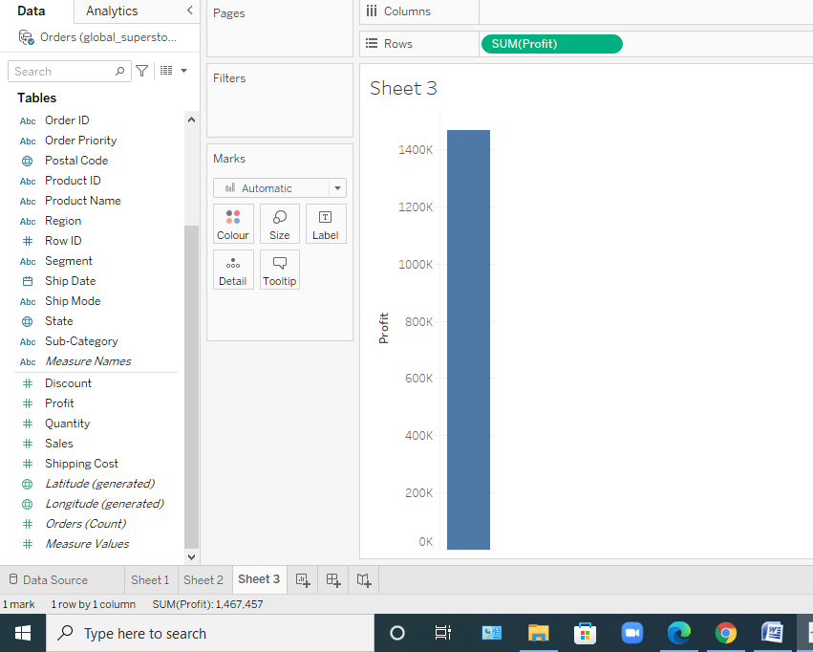

5.2 :-

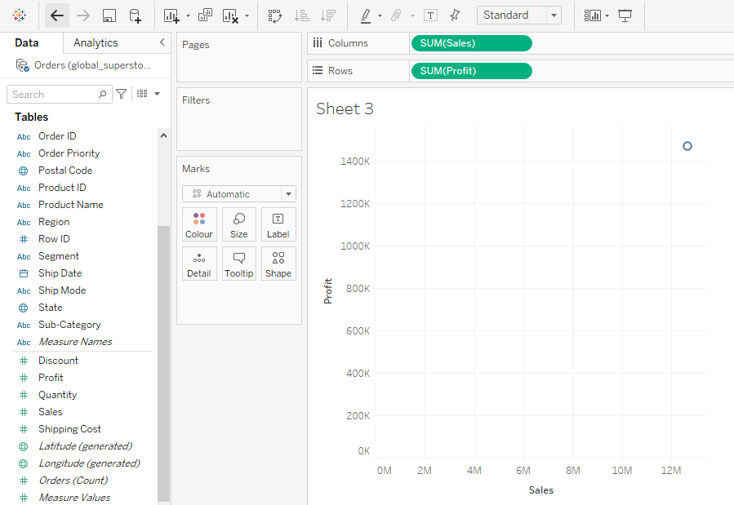

We can clearly take no insights from it but because we havenot used the data on which we have to find it so lets check and connect with country coloumn and get to see particularly about the USA Market.

STEP 6 :- In this step we selected the country coloumn and tried to analyse its data on the basis of world map.

6.1 As we clicked on the show map world Map option we got a very beautifull insight and in MARK attribute of tabkleau the profit and sum sales took place on its own.

6.2 we used the Mark up to decorate it like color and Label.

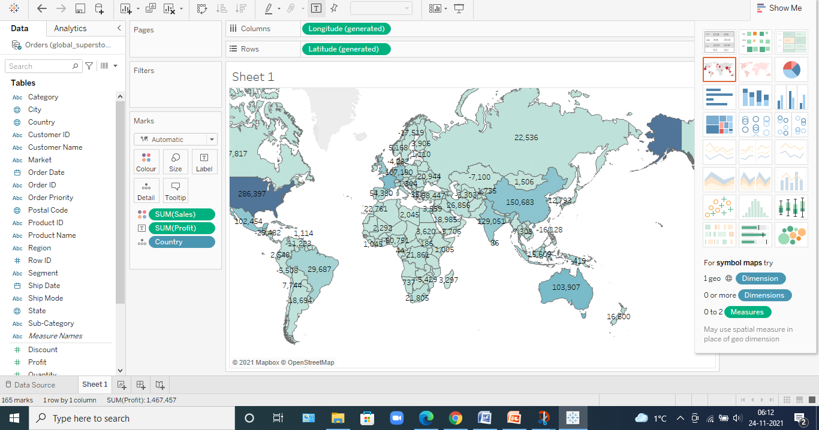

STEP 7: -

Now the problem that is rising is that that we only want the USA country so for tht to take place we dropped our dataset into the filter and selected a USA from the pop up arised.

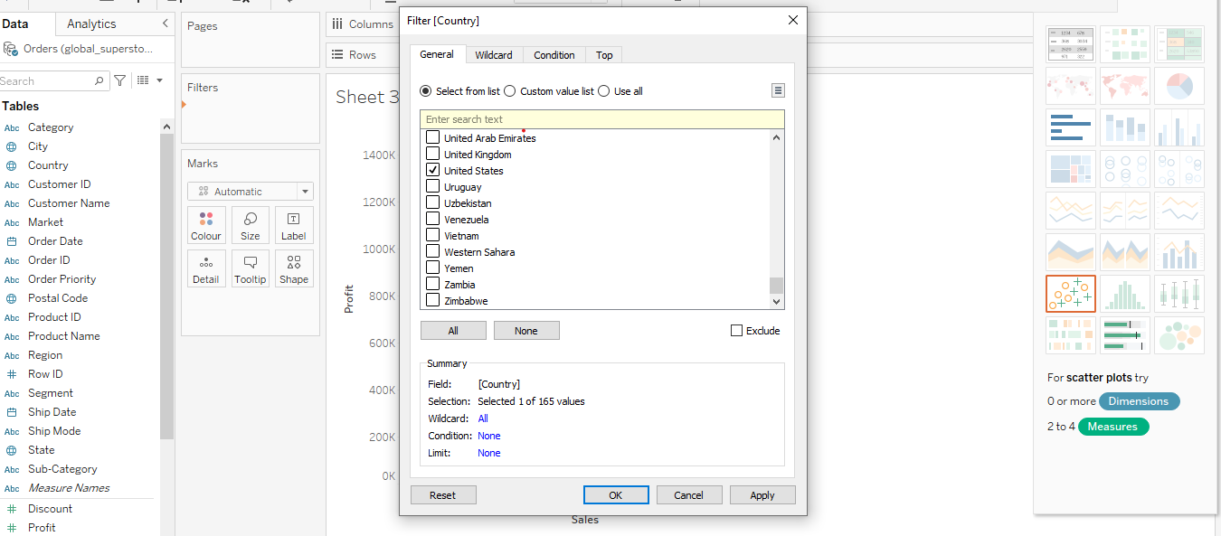

7.1 After this we need to select the state and look for profit and another stuff in it.

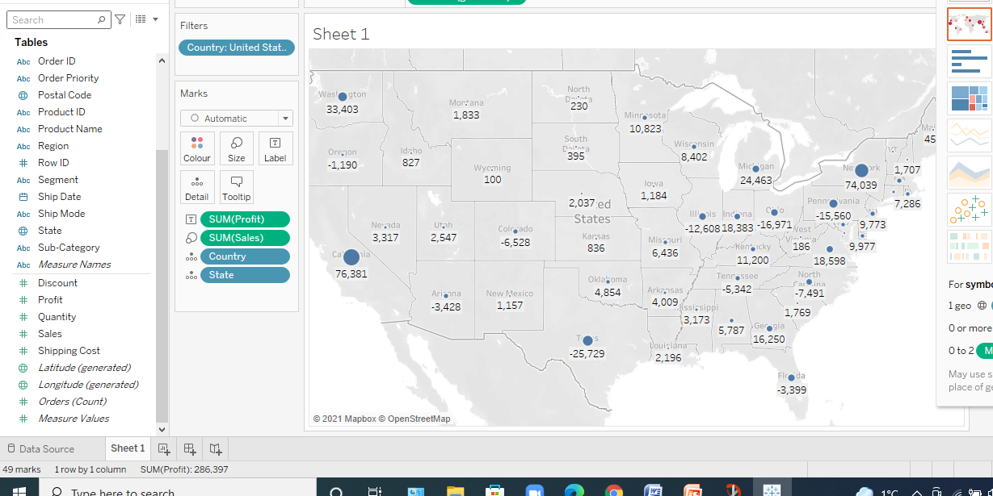

7.2 We got this at whole now that we have selected the states we wanted to color it on the basis of profit and sales so we placed the profit and sales on color palette of MARK.

Furthermore we tried to put sales on the basis of ts sixe and we got it.

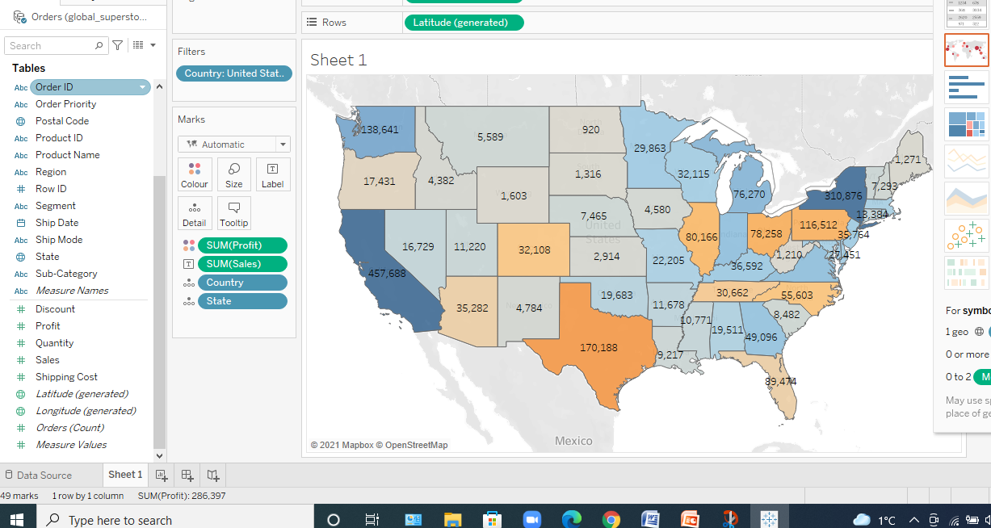

STEP 8: - Now that we have achieved all the tasks the final task is to get the analysis on the basis of categories in it and for that to take place we use category coloumn and placed it inside the filter of it and then choose all the subcategories we can and hence we got the subcategory of it .

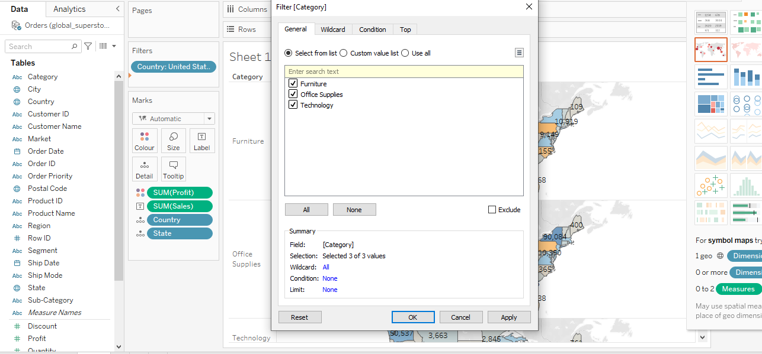

Without Applying subcategies we got this final analysis: -

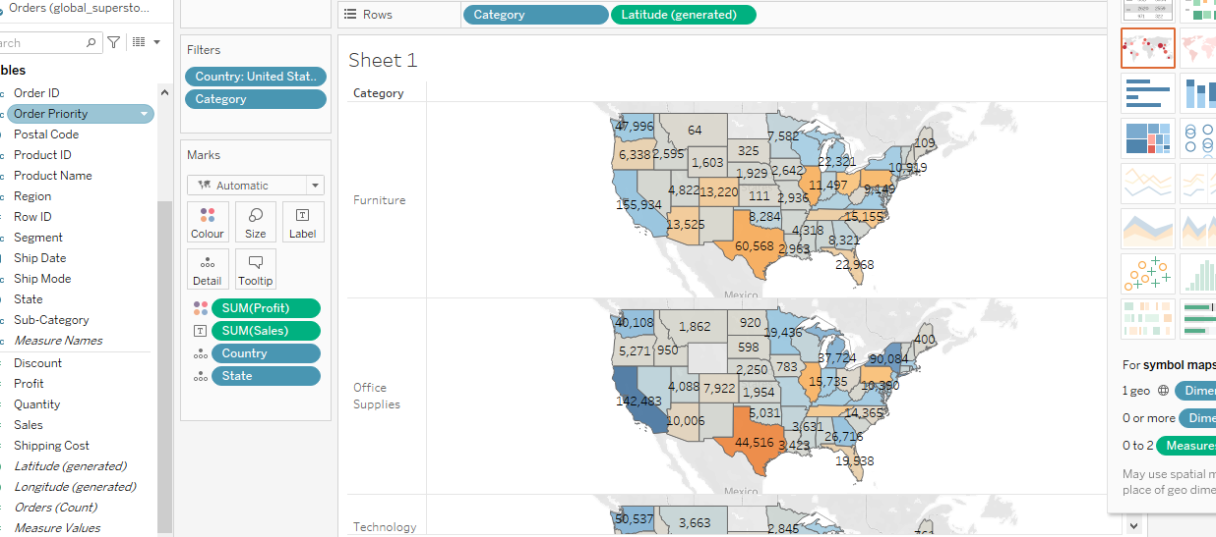

Lets explain this before moving further : -

We can see that we have been given 3 categories adnd hence we can drive the maxor min about the sales and profit earn in these states of United States.

Step 8.1 : -

Now we needed to find the sub category also so we did the same and but with these subcategories like appliances and bookshelves otherwise it would showthe above graph only : -

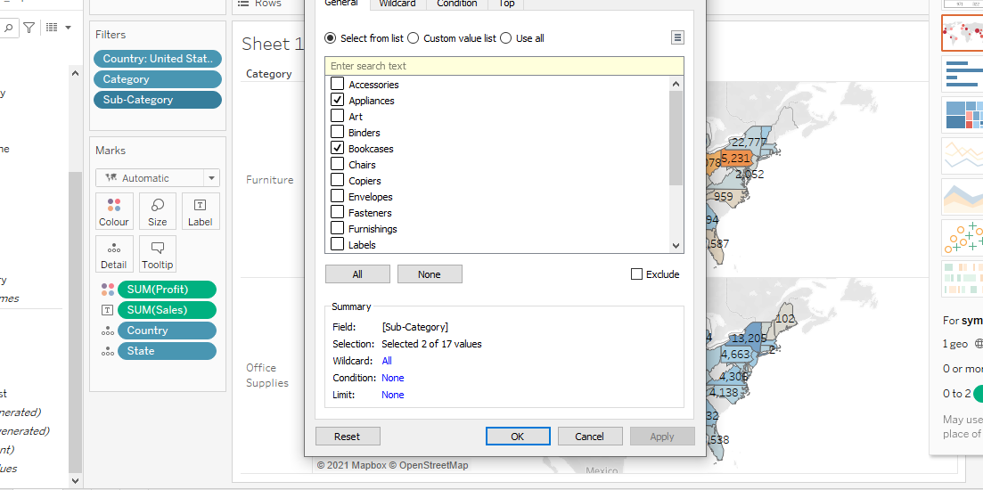

We applied it and lastly we got this : -

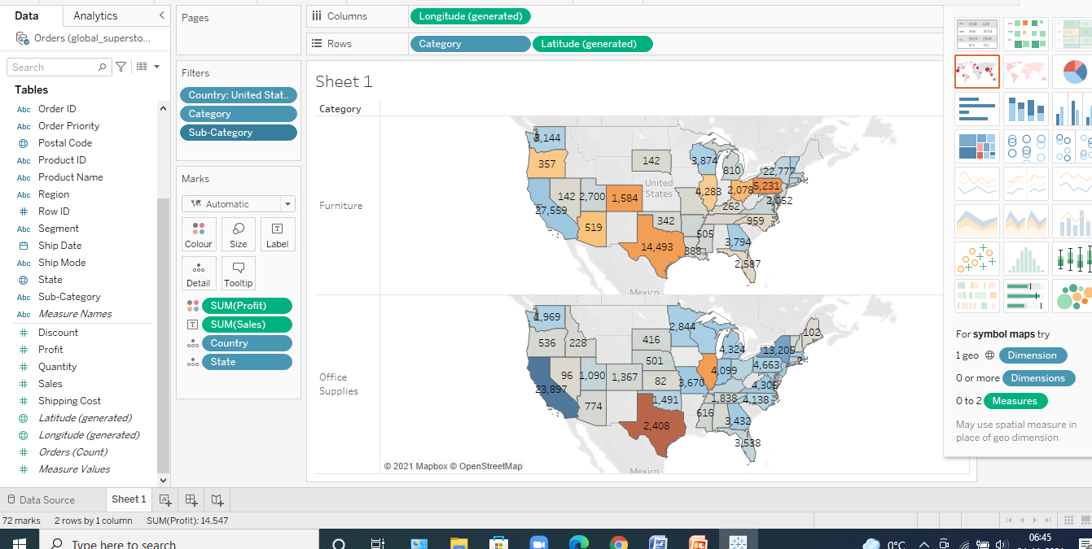

Lets Explain these analysis in our words : -

Over here our focus was to find the profit and the sales of only 2 items which we in subcategories and to find about max or min sale or whatever we want to find out.